KYC REQUEST LETTER

[ KNOWING YOUR CLIENT INFORMATION]

26 May 2020

Address :

Dear Sir
Know Your Client information
As you are aware, it is a requirement of raising capital in the London market that we conduct a Know Your Client exercise on all new clients.
For these purposes please supply the information specified below. Some of this information takes the form of answers to questions: please answer these questions to the full extent of your knowledge. Other information takes the form of official documents which we are required to obtain and photocopy. Ideally these official documents can be shown when we meet, and photocopies can be taken at that point; however, if we are not able to meet at the outset of the transaction then please email scanned copies to us, signed, or stamped, dated, and marked as “certified as a true and complete copy of the original” by a lawyer, accountant or public notary. In the case of certified copies, please provide in the covering email full details of the certifier, including his or her full name, email address, occupation and name of employer.
If the official documents are not in English, please provide an accompanying translation into English by a certified translator, and provide us with full details of the certified translator.
Please provide the following (uncertified) documents:
- a completed signed copy of Attachment 1 “Corporate information”;
- a completed signed copy of Attachment 2 “Source of Funds”;
- a list of current shareholders including percentages held, signed by the company secretary;
- a list of the current directors, signed by the company secretary; and
- a copy of the company’s anti-money laundering policy if there is one.
Please also provide the following official (certified) corporate documents:
- certificate of incorporation;
- memorandum and articles of association; and
- latest audited accounts.
For each individual owning or controlling 10% or more of the company’s share capital, and for at least two directors, please provide his or her name, date of birth and residential address, together with:
- a completed copy of Attachment 3 “Individual political exposure statement” (which does not need to be certified) and
- a resume (which does not need to be certified).
Please also provide for each:
- an official (certified copy) personal identity document and
- an official (certified copy) proof of address document.
The personal identity document can take the form of a current signed passport, a current signed national identity card or a current full driving licence bearing a photograph. The proof of address document can take the form of a bank, savings & loans institution or credit union statement containing the current address and dated within the past three months (private data can be redacted), current full driving licence bearing a photograph and current address (if this has not already been used as a personal identity document), a utility bill or equivalent dated within the past three months (NB mobile telephone bills are not acceptable) or a local authority property tax bill or equivalent, valid for the current year.
Each corporate entity owning or controlling 10% or more of the company’s share capital will need to provide the same Know Your Client information as the company.

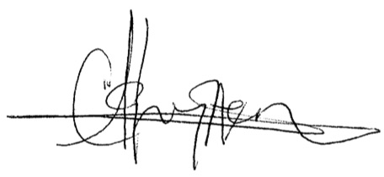
Yours sincerely

.......................................................

Clement J Aghayere, President
For and on behalf of Africa bridge capital management London UK Limited

